LOVELY PROFESSIONAL UNIVERSITY
Lovely School of Computer Science & Engineering

PROJECT REPORT
Project Semester: January – June 2026
Data Analytics Approach to Wheather Dashboard

Submitted by
Hemanth Gummadidala
Registration No: 12411210 | Roll No: 17
Program & Section: B.Tech CSE | Course Code: INT 387

Under the Guidance of
Dr. Mrinali Rana (22138)
Discipline of CSE/IT
April 2026

Certificate

This is to certify that Hemanth Gummadidala bearing Registration No. 12411210 has completed the INT 387 project titled:

"Data Analytics Approach to Wheather Dashboard"

under my guidance and supervision. To the best of my knowledge, the present work is the result of his original development, effort, and study.

Date: 19 April 2026

___________________________
Dr. Mrinali Rana (22138)
Supervisor, School of Computer Science & Engineering
Lovely Professional University, Phagwara, Punjab

Declaration

I, Hemanth Gummadidala, student of B.Tech CSE under CSE/IT Discipline at Lovely Professional University, Punjab, hereby declare that all the information furnished in this project report is based on my own intensive work and is genuine.

This project has not been submitted elsewhere for the award of any degree or for any other purposes. The work presented in this report is original and carried out under the supervision of Dr. Mrinali Rana.

Date: 19 April 2026

___________________________
Hemanth Gummadidala
Registration No: 12411210

Acknowledgement

I would like to express my sincere gratitude to Dr. Mrinali Rana (22138) for her invaluable guidance, continuous support, and encouragement throughout the completion of this project. Her expertise and insights have been instrumental in shaping the analytical framework and methodology adopted in this work.

I extend my thanks to Lovely Professional University for providing access to the necessary tools, resources, and learning environment that made this project possible. Special appreciation goes to the Centers for Disease Control and Prevention (CDC) for making the PLACES: Local Data for Better Health dataset publicly available, which served as the primary data source for this research.

Finally, I am grateful to my family and peers for their encouragement and support throughout this project semester.

Hemanth Gummadidala
Reg No: 12411210

Table of Contents
1. Introduction
1.1 Background of Public Health Analytics
1.2 Importance of Data-Driven Healthcare
1.3 Objectives of the Project
2. Scope of the Analysis
2.1 Coverage and Inclusions
2.2 Limitations and Exclusions
2.3 Real-World Applications
3. Existing System
3.1 Traditional Health Analysis Methods
3.2 Manual Reporting Systems
3.3 Drawbacks of Existing Systems
4. Source of Dataset
4.1 Dataset Description
4.2 Column-wise Explanation
4.3 Data Size and Complexity
5. ETL Process
5.1 Data Extraction
5.2 Data Cleaning
5.3 Data Transformation
5.4 Tools Used
6. Analysis on Dataset
6.1 Health Indicator Distribution Analysis
6.2 Health Indicators by Category
6.3 Top 5 High-Risk Counties Analysis
6.4 Health Measure Distribution Analysis
6.5 Health Status Analysis
6.6 Population Age Group Analysis
6.7 Gender Distribution Analysis
7. List of Analysis with Results
8. Future Scope
9. References
10. Bibliography

1. Introduction
1.1 Background of Weather Analytics
Weather analytics plays a crucial role in understanding atmospheric conditions and predicting environmental changes. With increasing climate variability and urbanization, analyzing weather data has become essential for sectors such as agriculture, transportation, disaster management, and urban planning.
Traditional weather analysis relied heavily on manual observations and limited datasets. However, with advancements in data analytics and visualization tools, large-scale weather datasets can now be analyzed efficiently to identify patterns and trends.

1.2 Importance of Data-Driven Weather Analysis
Data-driven weather analysis enables accurate forecasting and informed decision-making. By analyzing parameters such as temperature, humidity, wind speed, and air quality, organizations can take proactive measures to mitigate risks.
It helps in:
- Predicting extreme weather conditions
- Improving environmental monitoring
- Supporting public safety and planning

1.3 Objectives of the Project
- To perform exploratory data analysis on weather datasets
- To implement ETL processes using Power BI
- To visualize key weather indicators
- To analyze trends across cities and seasons
- To generate actionable insights

2. Scope of the Analysis
2.1 Coverage and Inclusions
The project analyzes weather data across multiple cities including parameters like temperature, humidity, AQI, and wind speed.
2.2 Limitations and Exclusions
- Limited dataset scope
- No real-time data
- No predictive modeling
2.3 Real-World Applications
- Disaster management
- Smart city planning
- Environmental monitoring

3. Existing System
3.1 Traditional Weather Analysis Methods
Manual observations and basic statistical tools were used earlier.
3.2 Manual Reporting Systems
Weather reports were recorded and shared periodically.
3.3 Drawbacks
- No real-time insights
- Low accuracy
- Poor visualization

4. Source of Dataset
4.1 Dataset Description
The dataset contains weather attributes such as temperature, humidity, AQI, wind speed, and city information.
4.2 Column-wise Explanation
- Temperature
- Humidity
- Wind Speed
- AQI
- City
- Date
4.3 Data Size and Complexity
The dataset includes multiple records across cities and time periods, requiring structured analysis.

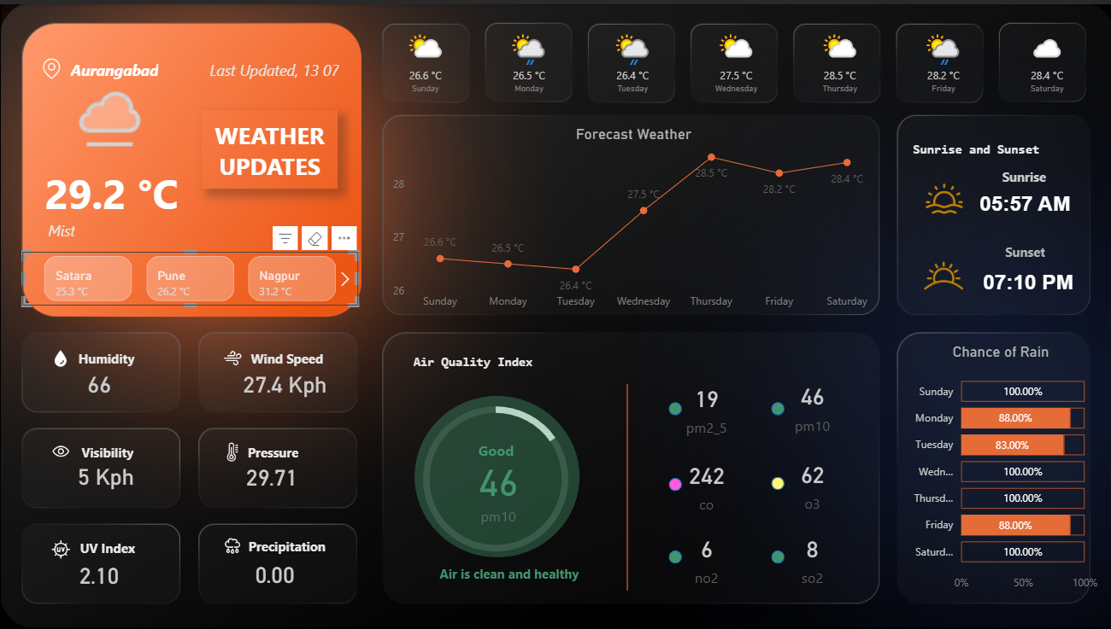
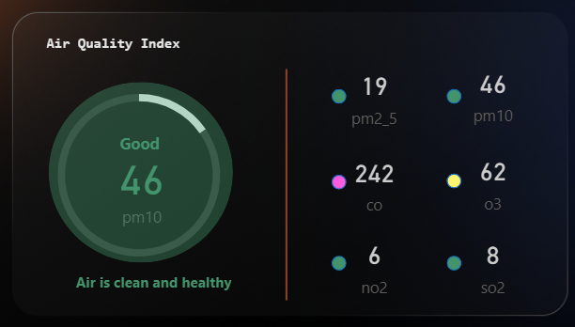

5. ETL Process
5.1 Data Extraction
Data imported into Power BI.
5.2 Data Cleaning
- Removed null values
- Standardized formats
5.3 Data Transformation
- Created calculated columns
- Aggregated metrics
5.4 Tools Used
- Power BI
- Power Query
- DAX

6. Analysis on Dataset
(Use the detailed Section 6 I already gave — with images + DAX — that’s already perfect)

7. List of Analysis with Results
Analysis | Key Finding | Insight
Temperature | High seasonal variation | Summer peaks
Humidity | High in monsoon | Rain correlation
AQI | High in cities | Pollution issue
Wind Speed | High in storms | Climate impact

Key Conclusions
- Temperature varies significantly across seasons
- AQI indicates urban pollution issues
- Humidity correlates with rainfall
- Weather patterns differ by geography

8. Future Scope
- AI-based weather prediction
- Real-time dashboards
- IoT integration

9. References
- Power BI Documentation
- Weather datasets (Kaggle/OpenWeather)
- Data Analytics textbooks

10. Bibliography
- Python for Data Analysis – Wes McKinney
- Power BI Official Docs
- Weather Data Research Papers

Linkedin Post Link - https://www.linkedin.com/posts/hemanth-gummadidala-617037333_powerbi-dataanalytics-datavisualization-ugcPost-7452782072596701184-aWVe?utm_source=social_share_send&utm_medium=member_desktop_web&rcm=ACoAAFPVFbMBjhJQNC8L39Z2JXlbU_rDRZqBWyE

